Version 2:

Callum J Warwick (CJW):

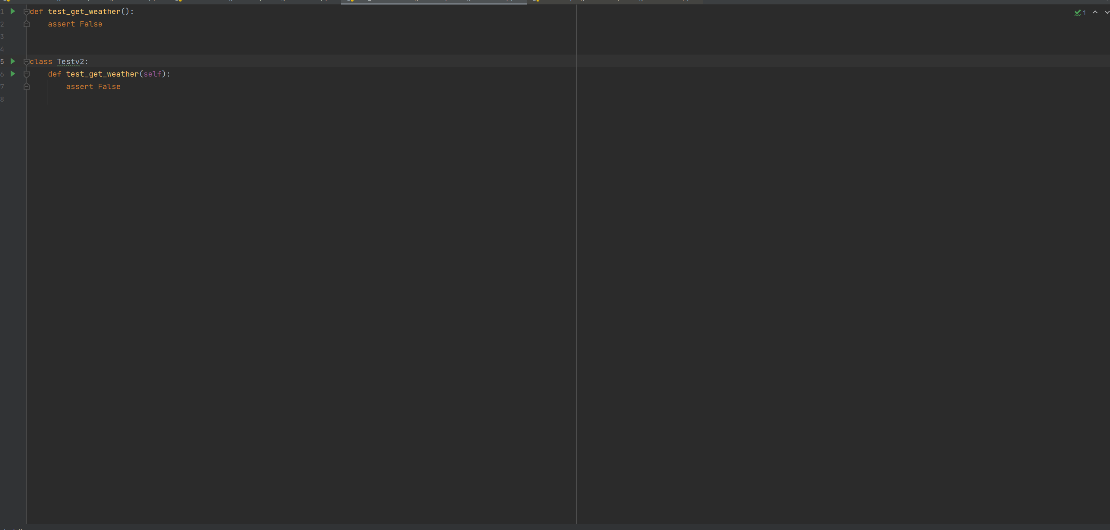



For version 2 of the code, running each function under the ‘PyTest’ and ‘Unittest’ packages, and all functions have returned okay, with exit code 0. I think also there should be an exit button, or an option to clear the process so users can start again without closing and re-running the app.

Incorrect or invalid entries also do not provide any data, which would be expected since the response from the API for ‘MMCDA’ should say that there is no city available. - CJW

**Unit measurements - Jonney**  
Looks like the issue where the units are not changing the degrees celsius unit label when the unit measurement is changed to imperial similarly to what was detected in version 1.0 which we thought could have potentially been addressed.  
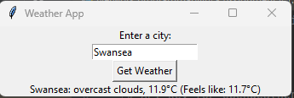

As stated in the previous troubleshooting and testing doc for v1.0, the fix would be to remove this string from the print output line within the code where it will detect the temperature unit based on its unit measurement.

**Country added into City search bar and Resolves – Jonney**  
When adding in the name of a country into the search bar for a city, it does resolve and reveals the weather for the entire country, it looks like this primarily looks at a city or town in Wales and provides that information back. To fix this we may need data validation methods put into place where it will error if a user enters a country name and then asks them to specify a valid location.  
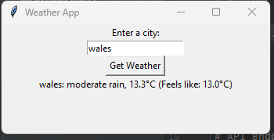

**Dynamic Window Sizing – Jonney**  
When opening the GUI on some occasions, it opens with the Window slightly expanded closed. A way to resolve this issue in future would be to specify a fixed window size within the code itself so users are unable to stretch this, and it will mitigate the risk of the Window opening extremely small at times.  


